Blackjack Trainer User Manual

Getting Started 1
Accessing the Game 1
System Requirements 2
Tutorial Mode 2
Game Modes 3
Standard Mode 4
Strategy Mode 4
Card Counting Mode 4

Getting Started

Accessing the Game
- You can access the game through itch.io, by searching blackjack trainer, published by tippacanoe.

- The direct link to the game is: https://tippacanoe.itch.io/blackjack-trainer
Its published Icon looks like this:
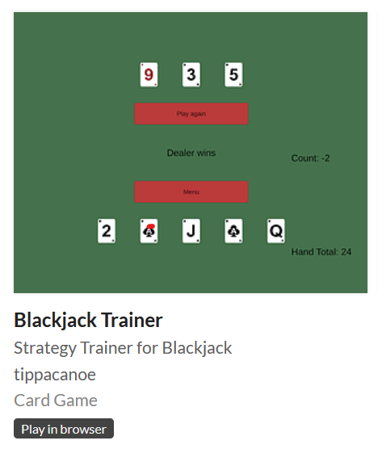
Upon clicking it you will be presented with a Run game button.
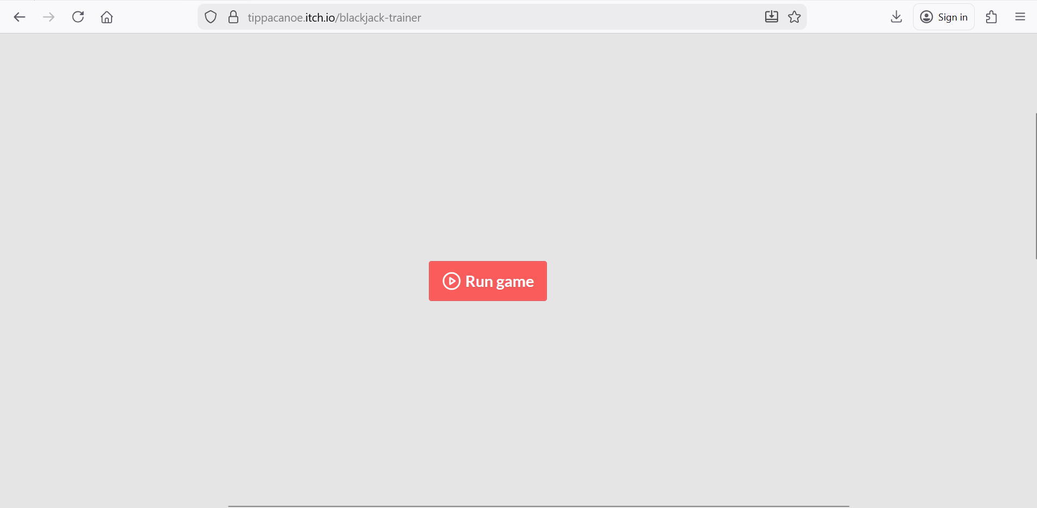

System Requirements
- Functioning web browser
- Compatible with Windows or Mac
- Web browser with javascript functionality
- At least 1 GB of RAM

Tutorial Mode
Upon launching the game, you will be met with three options.
- Play
- Tutorial
- Quit

Clicking the Tutorial button will present you with the rules of the game.
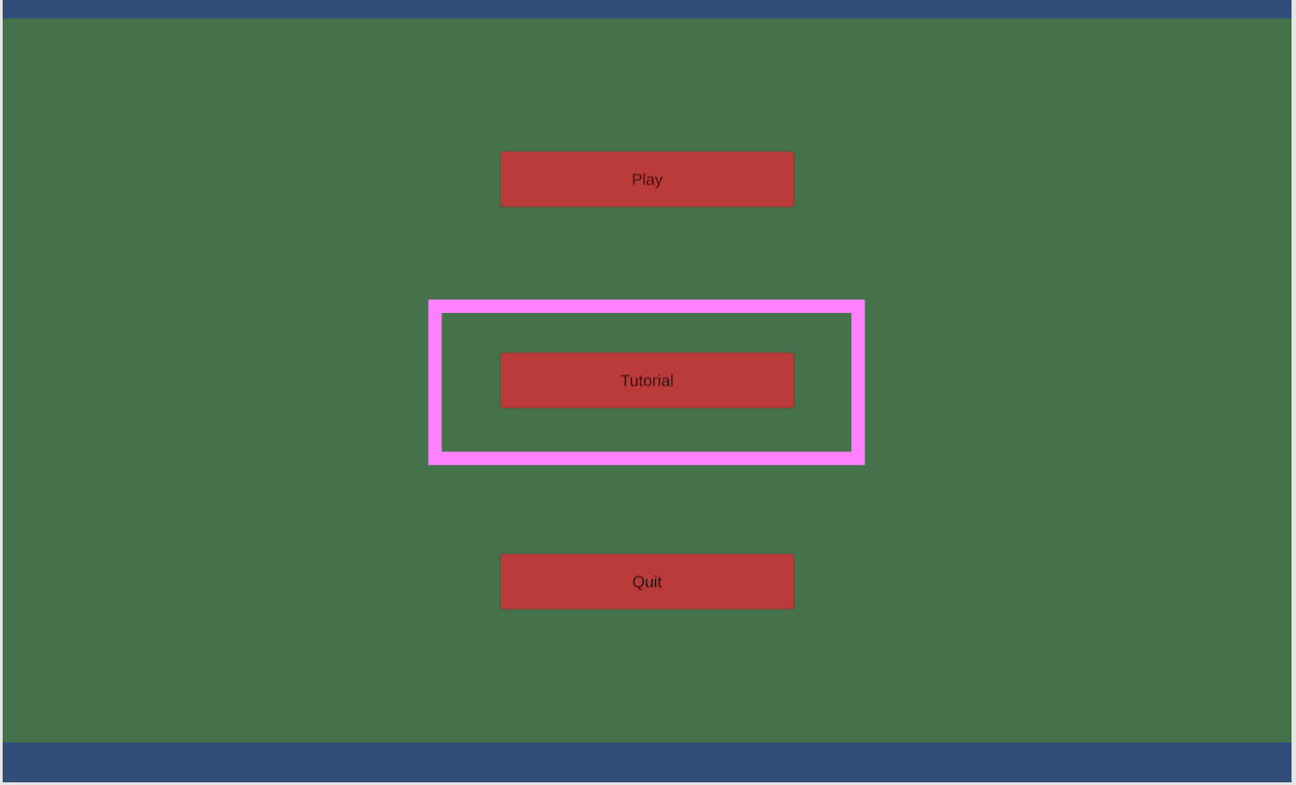

You can return to the main menu by clicking the Back button in the bottom left corner.
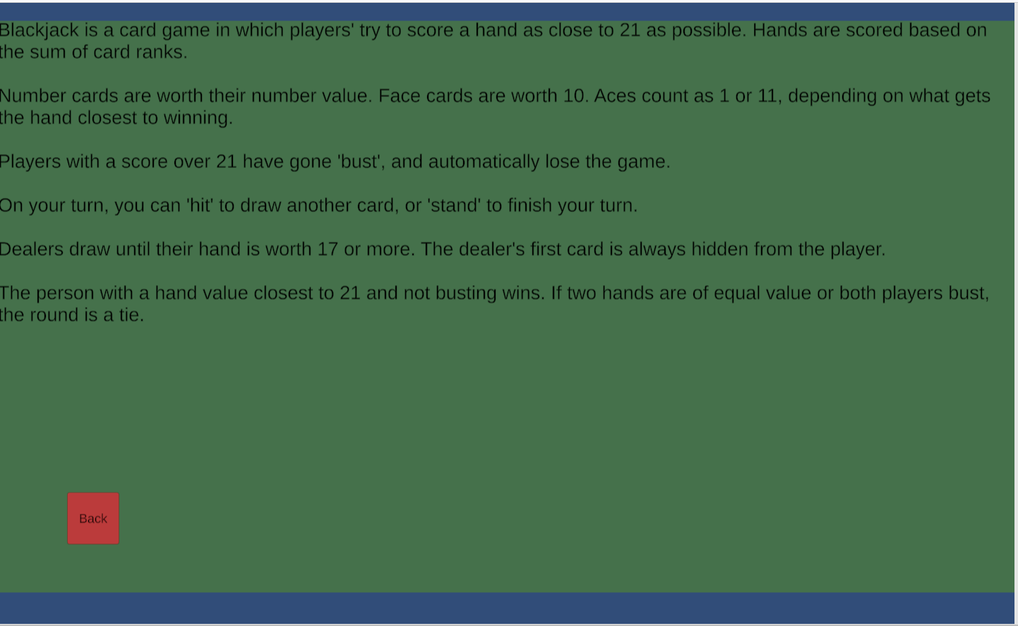

Quit
You can end the full game by clicking the third option, the Quit button.
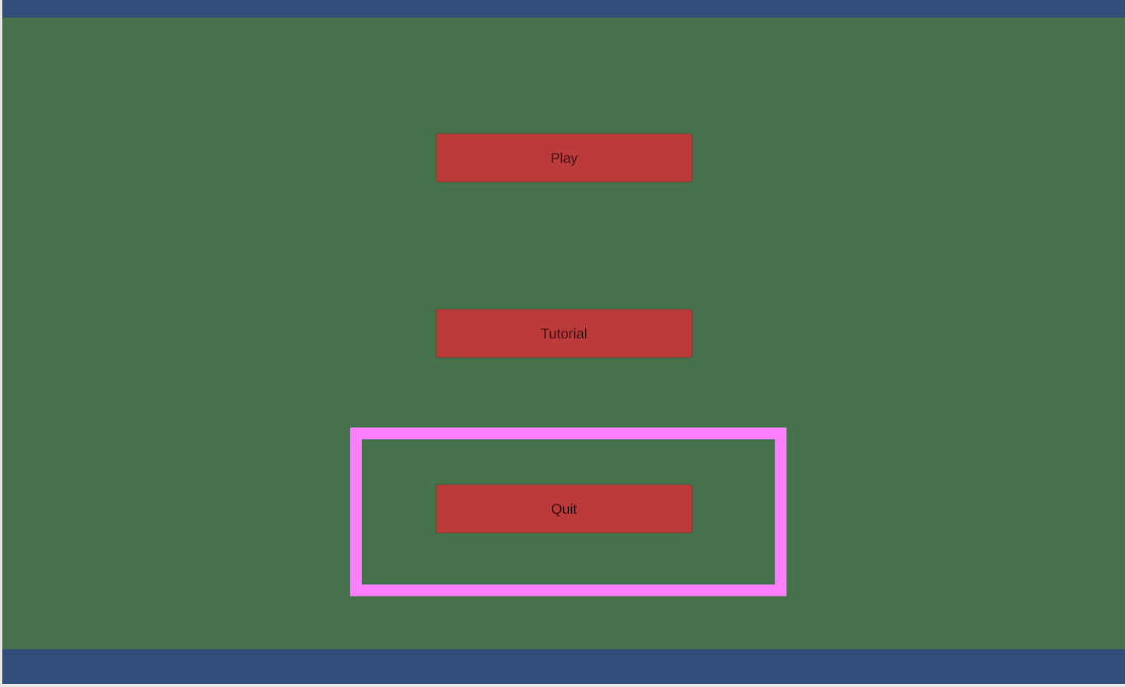

Game Modes

The game modes are accessed by selecting play on the home screen.
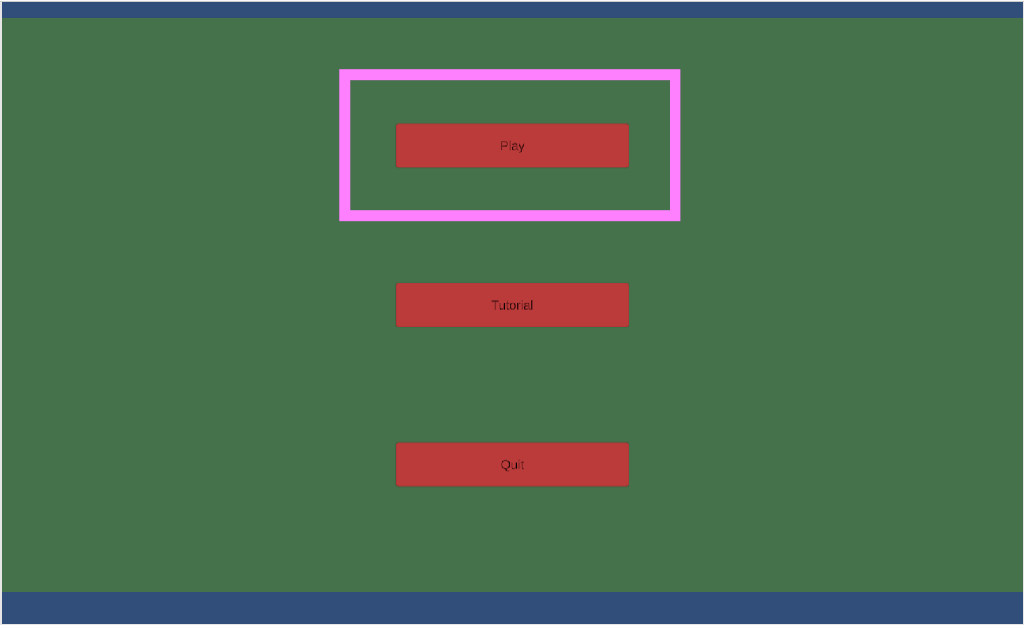

You will be given the three gamemode options along with a Back button that returns to the main menu.
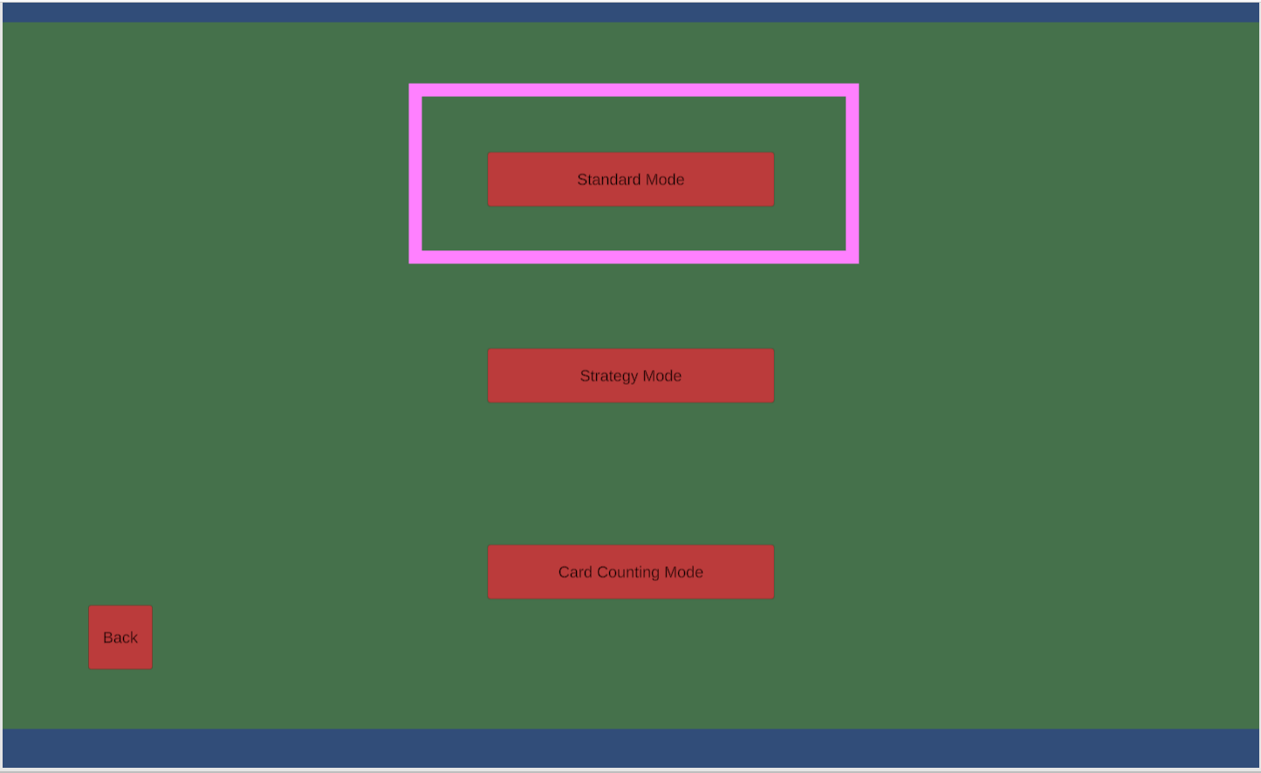

Standard Mode
Standard Mode is a free reign game of blackjack

Each round of standard mode entails the Dealer's hand and the Player’s hand. A hand total is included to aid the player in their decision. The player gets to choose between hitting and standing.
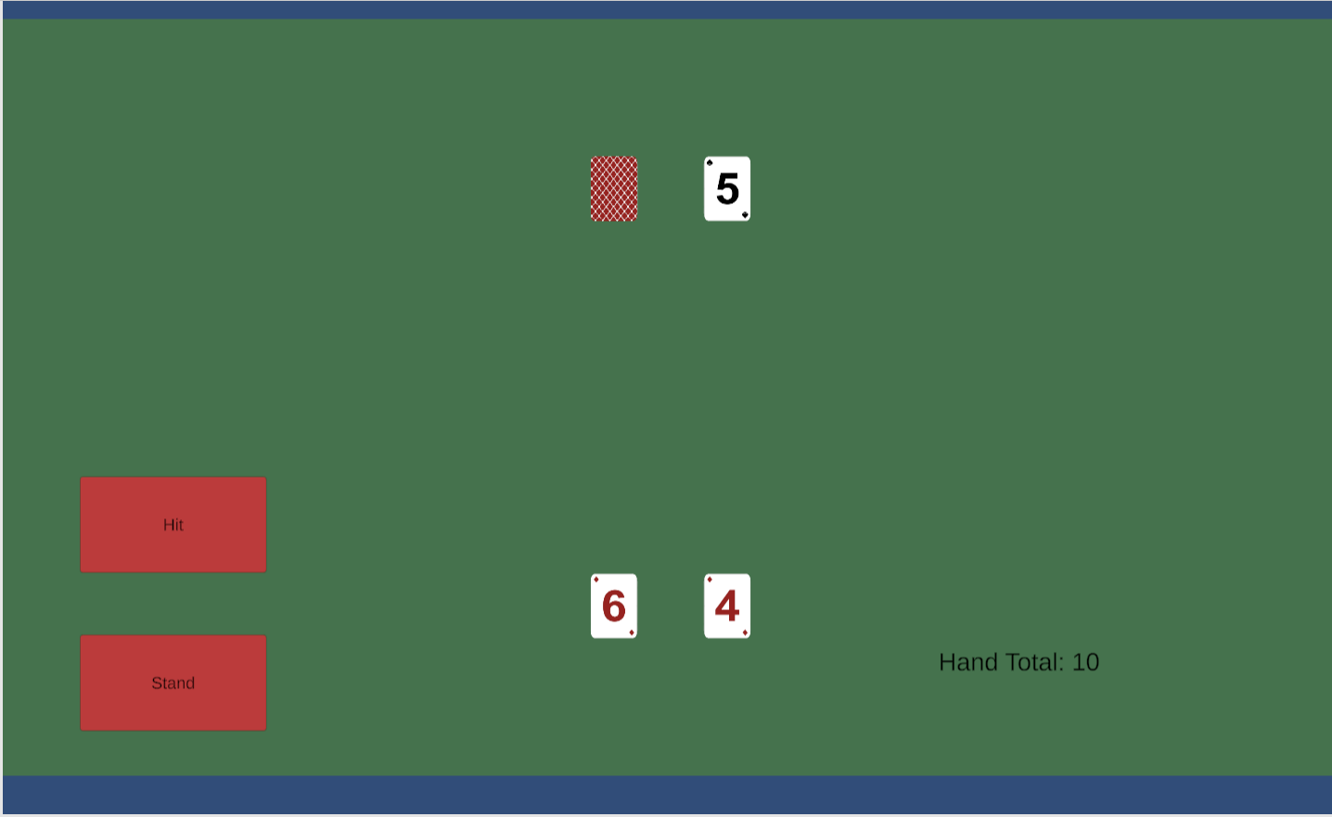

After each round the dealer’s complete hand is displayed. The dealer or player wins depending on which gets closer to 21. You will be given the option to play another hand with the Play again button, or you can return to the main menu with the Menu button.
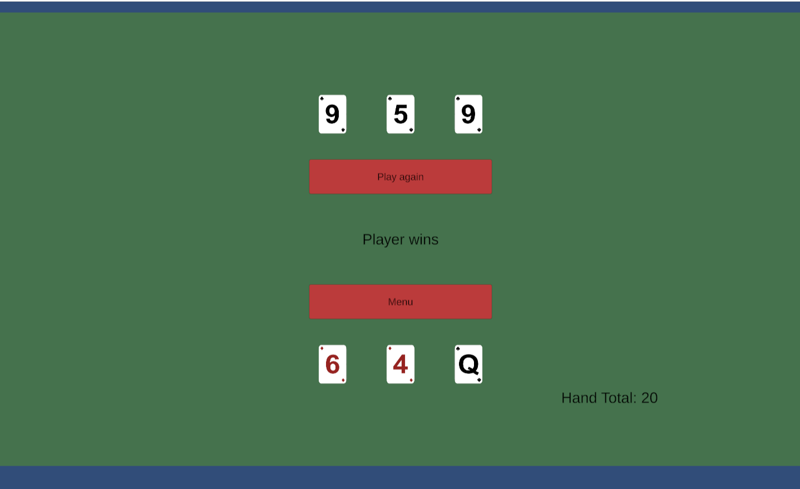

Strategy Mode
Strategy Mode differs from Standard Mode in that it explains to the player what the best move is. To play you must click the second button labeled Strategy Mode.
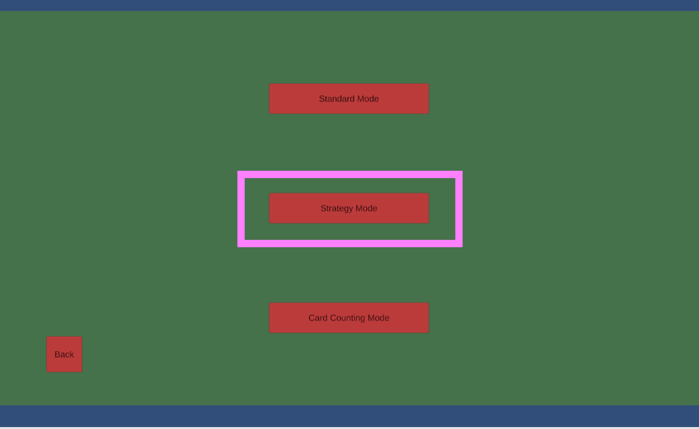
The layout is very similar to strategy mode with the exception of difficulty ratings on the side.
- Player Score Type
  - The harder the player score, the less likely you are to win.
- Dealer Known Value
  - The lower the dealer value, the less value their hand has.
- Player Hand Value
  - The higher the Player Hand Value the more likely you are to win
- Suggestion
  - Suggestion tells you which move is best with the given factors. You still have the option to disregard the suggestion.
The Hand Total is still included beneath the difficulty ratings.

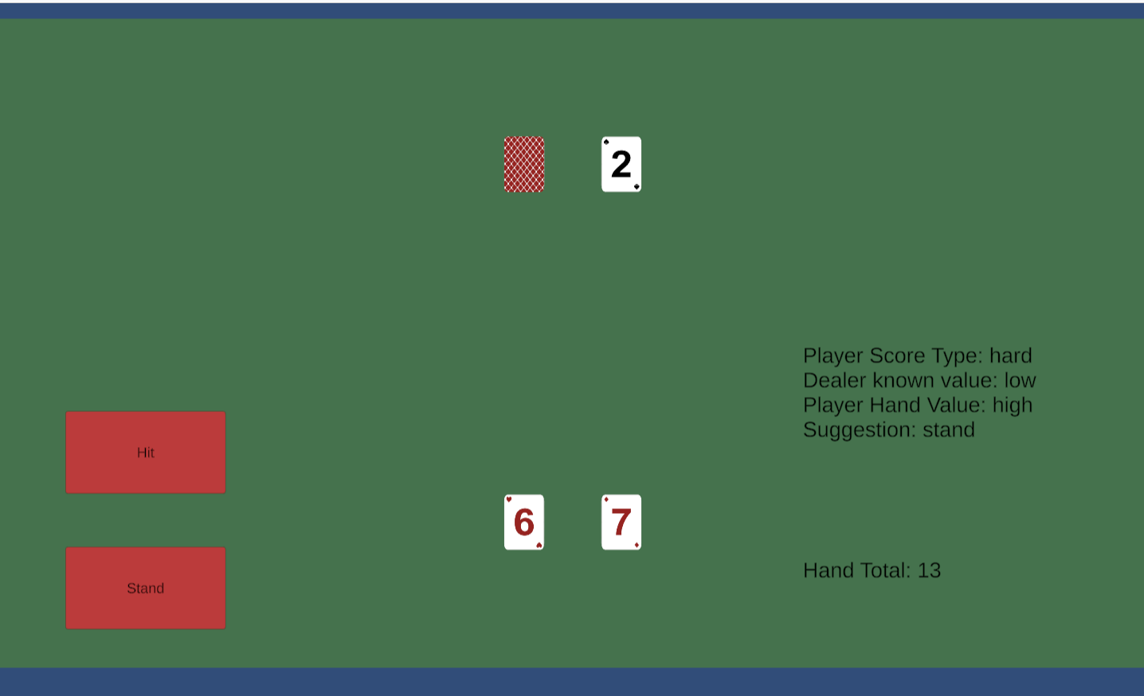

After each round the dealer’s complete hand is displayed. The dealer or player wins depending on which gets closer to 21. You will be given the option to play another hand with the Play again button, or you can return to the main menu with the Menu button.
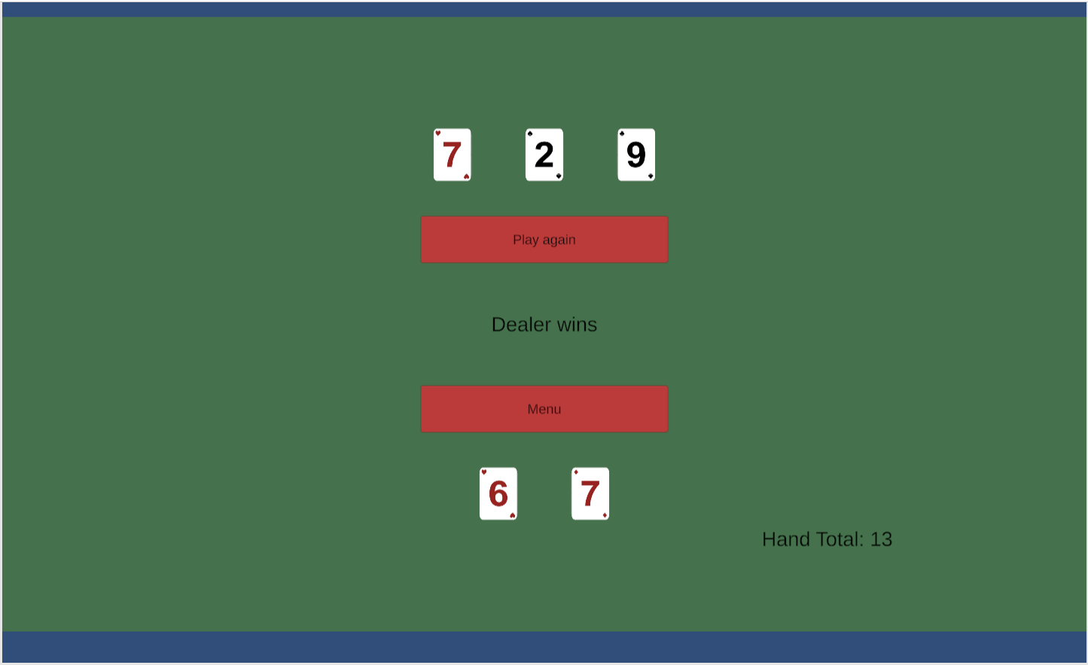

Card Counting Mode

Card Counting Mode teaches you how to keep a running count through multiple hands.
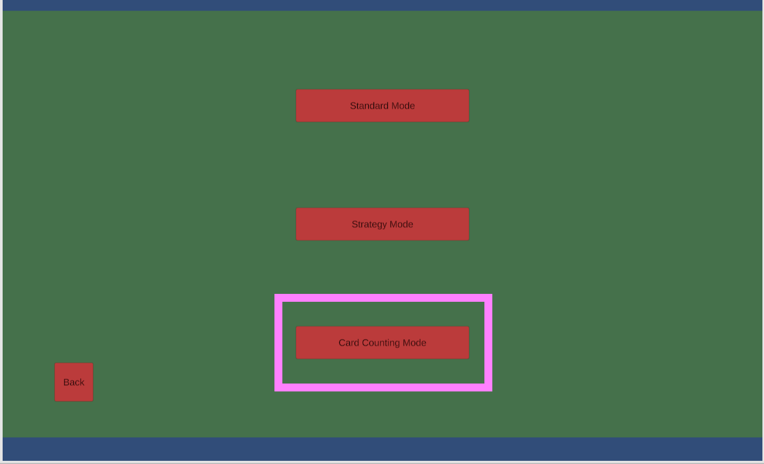

In this gamemode the Hand Total is displayed along with a Count total.
Each instance of:
- Cards 2-6 add 1
- Cards 7-9 add 0
- Cards 10-A subtract 1
The higher the count, the better the odds are for the player. The Count is automatically updated for the player.
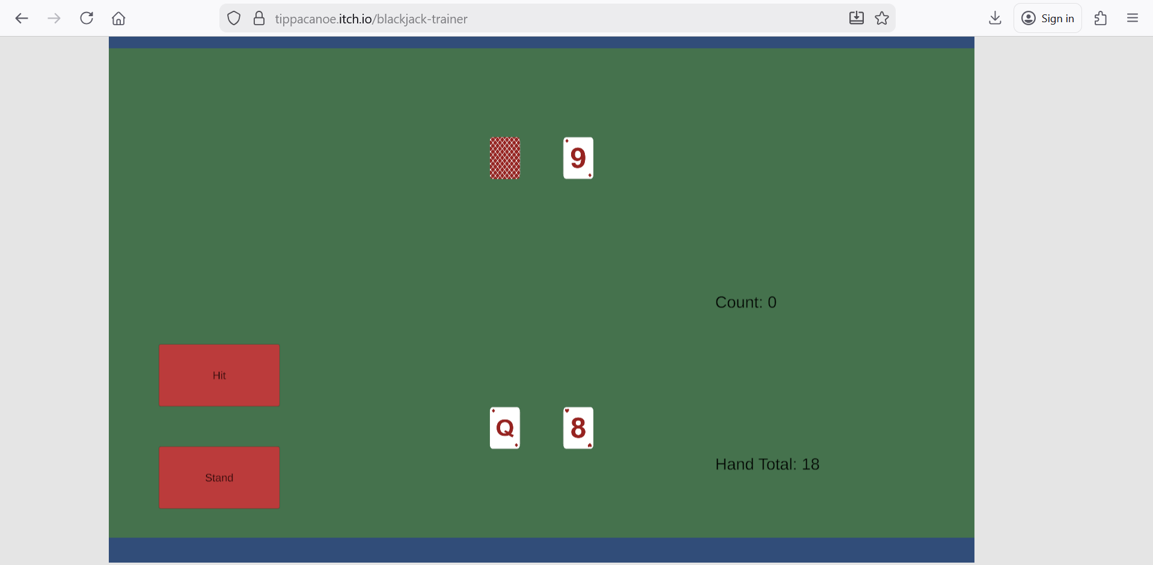

The count gets updated at the end of each round. You will be given the option to play another hand with the Play again button, or you can return to the main menu with the Menu button.
